PMIS Snapshot

Group 30 – Nuvven Partner App

Lewis Green – 40314971

Thomas Byers – 40321580

Joe Marshall Brydson – 40323478

Hedwin Coursimault – 40442705

Zakaria Slifi – 40444259

Table of Contents

Project Summary ………………………………………………………………………………… 1

Business Case ………………………………………………………………………………… 2

Configuration Map ………………………………………………………………………………… 3

Schedule Model ………………………………………………………………………………… 4

MoSCoW Prior. ………………………………………………………………………………… 4

RIC Register ………………………………………………………………………………… 5

Client Approval ………………………………………………………………………………… 6

Project Summary

Nuvven Partner Mobile App

Dates

|  |  |  |
| --- | --- | --- |
| Sponsor Appointed | Project Authorized | Project Closed |
| Brian Davison |  |  |

Purpose

|  |  |
| --- | --- |
| Goal / Outcome | To create a mobile application as a partner to SaaS platform. |
| Main product | A multi-platform mobile application. |
| High-level Requirements | Enables car rental workers to deliver and collect rented vehicles, and perform related administrative tasks. |

Targets

|  |  |
| --- | --- |
| Duration | 06/01/2020 – 06/04/2020 |
| Budget | N/A |

Major Risks

|  |
| --- |
| Security; protecting the data, planning, and execution associated with the project. Project completion and quality; time management of team members involved, loss of progress through lack of backups. |

Roles

|  |  |
| --- | --- |
| Sponsor | Brian Davison |
| Consultants | Kyle Wernham, Catherine George |
| Project Manager | Lewis Green |
| PM Support(s) | N/A |
| Team Manager(s) | N/A |
| Supplier PM(s) | N/A |

Business Case

Nuvven Ltd. Companion App

Business Purpose for doing the project

|  |
| --- |
| This companion app will be used in conjunction with the Nuvven SaaS platform, to enable car rental employees to deliver and collect rental vehicles, and perform appropriate administrative tasks while out of office. |

Expected Benefits

|  |
| --- |
| Allows users of the SaaS platform to liaise with customers, and perform administration tasks on the move that cannot be performed in office. This improves the convenience of the SaaS platform. Allows employees to perform tasks that would be more inconvenient otherwise. |

Expected Dis-Benefits

|  |
| --- |
| Requires employees to carry a smartphone with the application downloaded, an appropriate level of charge, and a mobile data connection for best use. All data is held on a single centralized server, and so any problems that occur on the server side would affect the majority of devices. Software must be maintained after the project’s completion. |

Expected Cost

|  |
| --- |
| Time Cost: this project will take place over 13 weeks. The first 4 weeks spent on project set up, the next 7 weeks spent in development, and the final 2 weeks to close the project. Financial Cost: the Nuvven Ltd. will provide access to software and services required to complete this project. |

Major Risks

|  |
| --- |
| Security: protecting the data, planning, and execution associated with the project. Project completion: time management of team members involved, loss of team members. Project Quality: loss of progress through lack of backups, unclear or messy code, merge conflicts. |

Configuration Map.

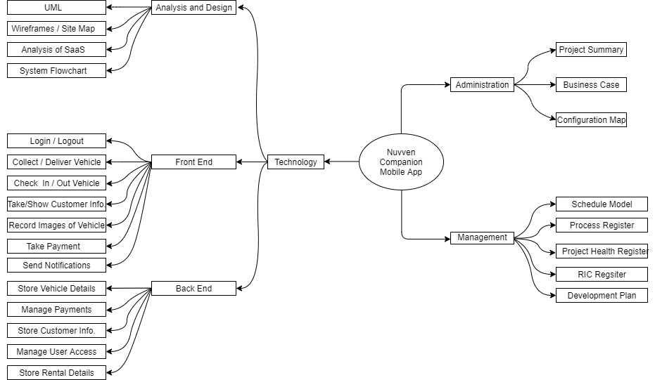

Schedule Model

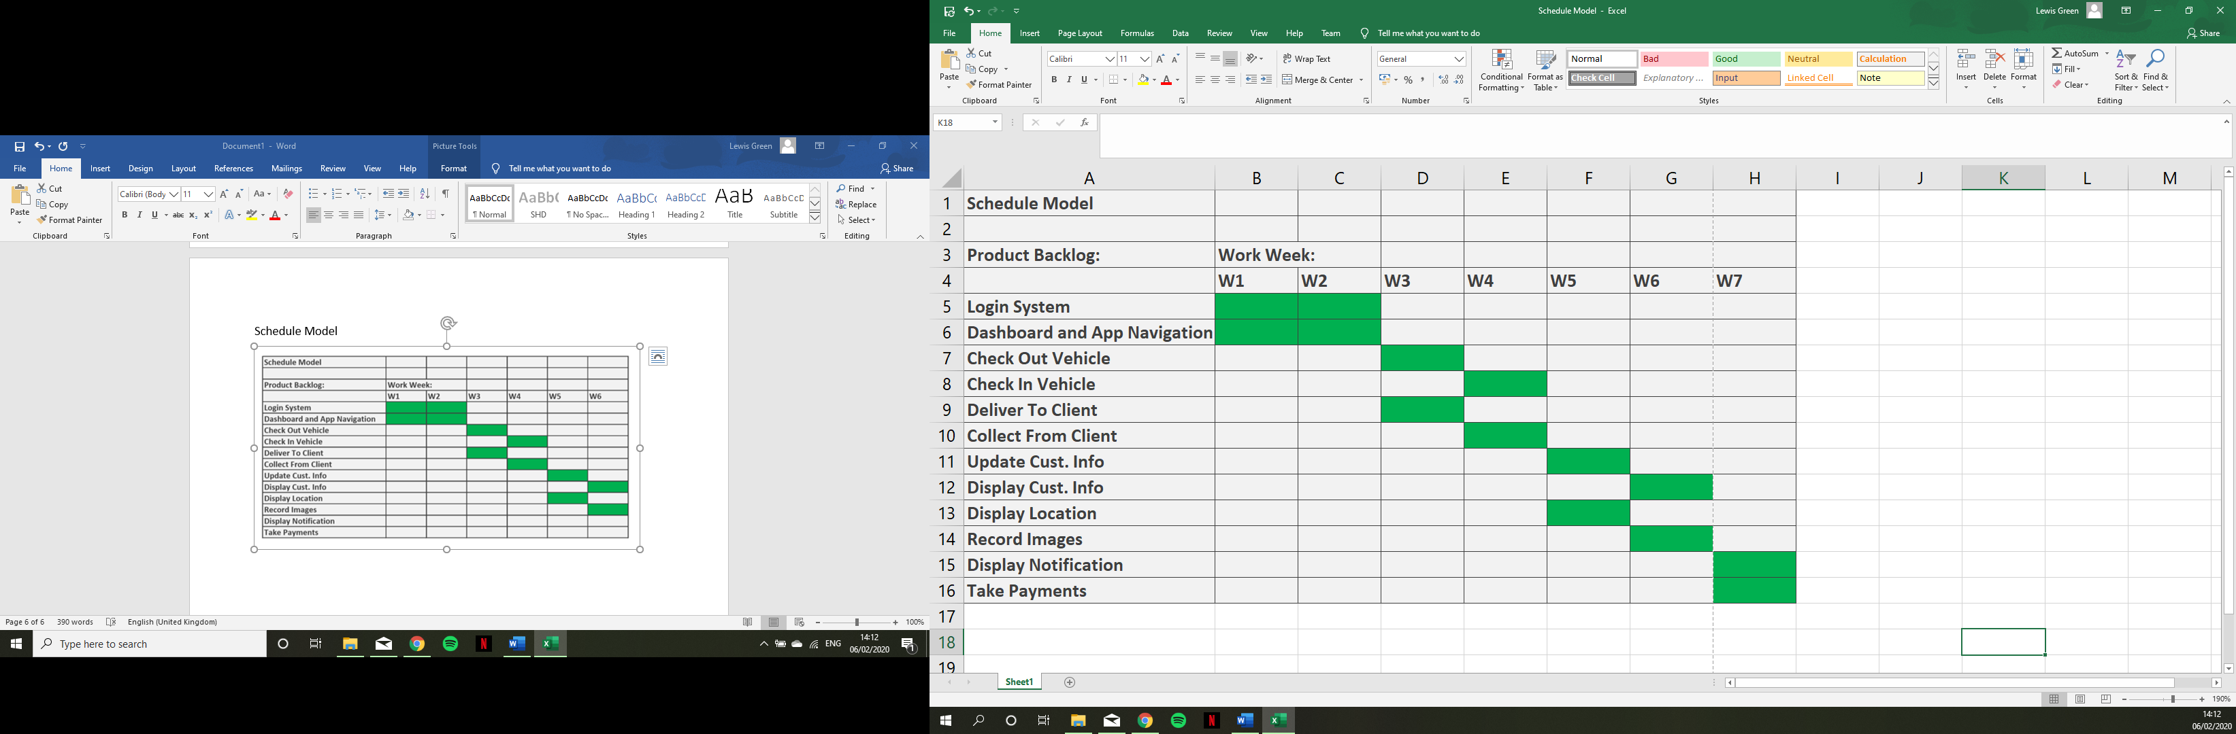

MoSCoW Prioritisation

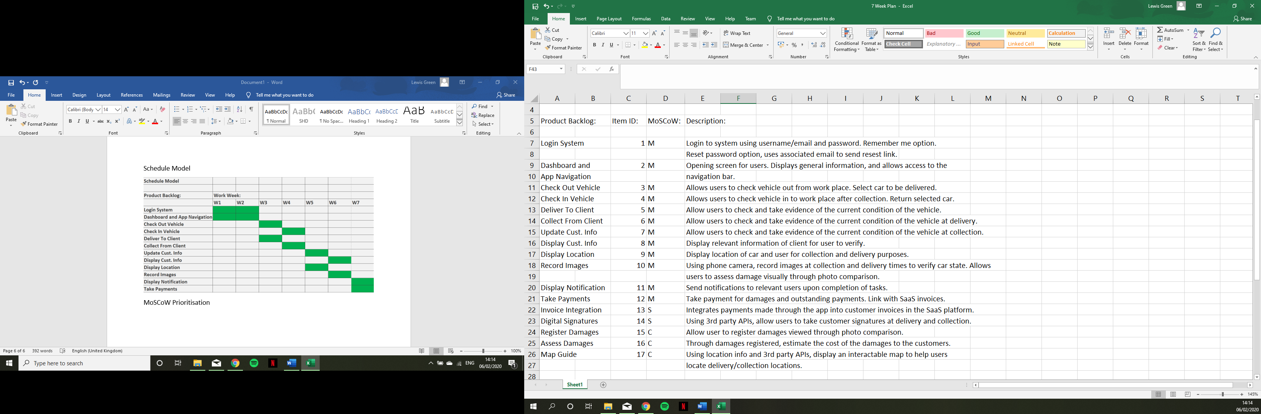

RIC Register

